Quantum Support Vector Machine (qSVM) Classification Tutorial Demonstration

Summary

The goal is this project is to leverage a quantum based support vector machine classifier algorithm to train and test a qSVM model on a custom EUDUSD analysis dataset. In particular, the objective of the qSVM classifier is to correctly classify EURUSD buy and sell positions. It is important to note that the initial data provided to the project is reduced to input dimensions via principal component analysis (PCA). We utilize the Qiskit Aqua code from the following Github repository for this project:

https://github.com/Qiskit/qiskit-community-tutorials/blob/master/artificial_intelligence/qsvm_multiclass.ipynb

There are two primary results from this tutorial:

1. A scatter plot graph of the dataset (after dimension reduction via PCA). The colors represent buy (blue), sell (orange), and hold (green) positions.

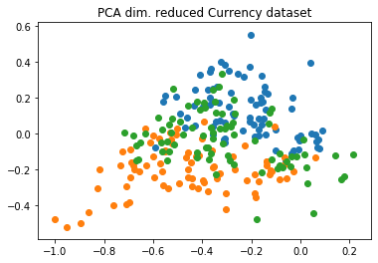

2. The “testing accuracy”, which is a decimal value representing the percentage of classifications that were correct.

'testing_accuracy' : 0.5666666666666667

Background

Qiskit Aqua

“Aqua is where algorithms for quantum computers are built. These algorithms can be used to build applications for quantum computing. Aqua is accessible to domain experts in chemistry, optimization, finance and AI, who want to explore the benefits of using quantum computers as accelerators for specific computational tasks.”

Data

Our data comes from various sources that compile publicly available data. Our data sources include Bloomberg, TradingEconomics.com, and fred.stlouisfed.org. The data set includes several metrics on the US economy and the EU economy as well as values of EURUSD prices. Scored Values of the metrics were generated using excel. We also created a classification variable, Position, to determine whether a particular observation warranted a “buy”, “sell”, or “hold” position.

Jupyter Notebook

The jupyter notebook file for this tutorial is located at the following Github link:

Additional github links that detail several of the methods specific to Qiskit Aqua algorithms utilized in this notebook are listed here:

https://github.com/Qiskit/qiskit-aqua/blob/master/qiskit/aqua/algorithms/many_sample/qsvm/qsvm.py

https://github.com/Qiskit/qiskit-aqua/blob/master/qiskit/aqua/input/classification_input.py

https://github.com/Qiskit/qiskit-aqua/blob/master/qiskit/aqua/components/feature_maps/second_order_expansion.py

https://github.com/Qiskit/qiskit-aqua/blob/master/qiskit/aqua/components/multiclass_extensions/all_pairs.py

Additional links to Qiskit Aqua references:

https://qiskit.org/documentation/apidoc/aqua/aqua.html#qiskit.aqua.run_algorithm

https://qiskit.org/documentation/apidoc/aqua/input/input.html#qiskit.aqua.input.ClassificationInput

